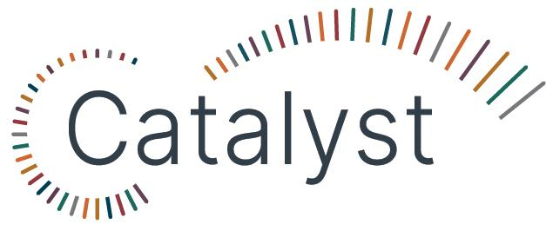

Leadership Program Application 2026 Information and Questions

Program Information
Thank you for your interest in Catalyst, California’s statewide library leadership program. Catalyst is designed to equip and support California library workers with development opportunities that allow them to lead from anywhere.

If your application is chosen, you will join a learning cohort that is scheduled to meet for a total of 12 months, starting in September 2026. Throughout the program, the cohort will meet both online and in-person to learn, reflect, and work on projects that apply new leadership skills and ideas. The time commitment will be about 4 hours per week on average.

Required monthly cohort meetings will be held on the third Friday of each month from 1:00–2:30pm (starting on September 18, 2026). Additional required training (both synchronous and asynchronous) will also be scheduled throughout the program.

Participants must also be available to attend two in-person sessions: Tuesday, Oct. 13– Friday, Oct. 16, 2026 at the Asilomar conference center near Monterey, and a second meeting in March 2027 in Southern California (anticipated dates and location: March 10–12, 2027, San Diego; final dates and location are being confirmed.)

Applications are due by Thursday, August 20, 2026 at 11:59pm. After the deadline, California library leaders and CALL staff will review all applications anonymously. The highest-scoring applications will then receive a final review to ensure the cohort includes participants from a variety of regions, library types, jurisdictions, and roles across California. CALL will inform all applicants of their status by Tuesday, September 1, 2026.

Have questions about Catalyst? Join Office Hours to connect with Maddy Walton-Hadlock, Catalyst Facilitator, and get one-on-one support. Sign up for office hours. An FAQ is also available for your reference on the Catalyst website.
You can also contact Maddy Walton-Hadlock at mwaltonhadlock@cla-net.org.

This program is brought to you by California Libraries Learn (CALL). CALL is a collaborative project of the California Library Association and the California State Library, and is supported in whole or in part by the U.S. Institute of Museum and Library Services under the provisions of the Library Services and Technology Act, administered in California by the State Librarian.

Questions

Section 1 - General Information

First and Last Name

Email Address

Phone Number

Workplace

Job Title (Please include a short description of your role if your job title is not self-explanatory.)

Number of years you have worked in libraries:

Describe your library community. (Check all that apply.)
  - Tribal
  - Rural
  - Small
  - Suburban
  - Urban
  - Other

Describe your library type.
  - Public
  - Academic
  - School
  - Special
  - Other

Your Library Director/Principal/Dean's Name and Email Address

Your Direct Supervisor's Name and Email Address (if different from above)

Have you had a conversation with your supervisor, manager, or director about the time commitment this program will require over the next 12 months?
  - Yes
  - No
  - Other

Section 2 - Share your thoughts
Read each question carefully and write a response that highlights your unique perspective and experience. Aim for answers that are about 100-200 words long-- not too short, but not too long. You might want to draft your answers in a separate document and insert the final version here.

Share a little about your background and the professional or personal experiences that shaped your interest in leadership and Catalyst.

Please share a time when you demonstrated leadership, regardless of whether you held an official leadership position or not. What skills and personal strengths played a role in your success during this experience?

Share an example of a time when you tried a new process or approach, either in your work or personal life, despite it being unfamiliar or outside your comfort zone. How did you handle the situation, and what was the outcome?

What else would you like to share with us about yourself? (Work experience, membership in library or community organizations, awards, hobbies, life experiences, etc.)

What would you like to learn in the Catalyst program?

Have you ever participated in a leadership development program previously? If yes, please describe it (who was the provider, how long was it, what topics were covered.)

Section 3 - Agreements
Please read the Catalyst program requirements below and indicate that you agree.

I agree to participate in regular virtual cohort activities, including monthly meetings and required trainings. The time commitment is about 4 hours/week on average.
  - Yes
  - No
  - Other

I agree to attend two in-person sessions: Tuesday, Oct. 13– Friday, Oct. 16, 2026 at the Asilomar conference center near Monterey, and a second meeting in March 2027 in Southern California (anticipated dates and location: March 10–12, 2027, San Diego; final dates and location are being confirmed.) Funds for travel and lodging will be provided.
  - Yes
  - No
  - Other

I agree to be engaged and actively involved in cohort activities and the process of my own leadership development, including a mentorship relationship.
  - Yes
  - No
  - Other

I agree to embrace challenging conversations as a pathway to growth and development. I will try my best to remain open when faced with new ideas from the cohort, especially those that strengthen our ability to serve all members of our communities.
  - Yes
  - No
  - Other

I agree to share the knowledge and skills that I learn through the Catalyst program with my library colleagues.
  - Yes
  - No
  - Other

I agree to explore at least one new role I can take on now or in the future to learn about leadership. (This role could be as a member of a professional interest group or organization, participating in a community organization, or taking on a new group responsibility at the library.)
  - Yes
  - No
  - Other

Even with the support of your library, supervisor, and colleagues, you may still find that you need to participate in Catalyst activities outside your work time. I agree to commit to that time, as needed.
  - Yes
  - No
  - Other

Section 4 - Additional Information
Optional: if you would like to share your resume or any other supporting materials with the Catalyst team, please email your documents to Maddy Walton-Hadlock at mwaltonhadlock@cla-net.org.

