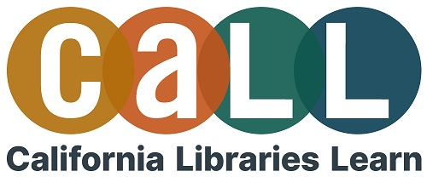

Project and Program Planning
Curated Training List

Whether you are new to project and program creation or well-experienced, there are always new methods and approaches to try. Check out these suggested tutorials in CALL Academy to learn more about this topic:

Getting Started
- Project Management Essentials for Libraries
- Planning Like a Project Manager
- Community-Centered Program Development

Evaluating Program Success
- Evaluation for Program Planning and Decision-Making
- Knowing When to Let Go: Ending Services and Projects Strategically

Customize It
- Planning programs for Youth: Child Development
- Ideating Programming for Spanish Speakers
- Contexts, Connections, and Cultures: Planning for Community Engagement and Culturally Responsive Evaluation
- . . .and so much more in the Programming Category

Process and Discuss
The following learner guide is for your personal use and is intended to encourage you to take what you have learned, apply it, and share it when relevant.
- CALL Learner Guide

